Libgdx-ai

(pathfinding)
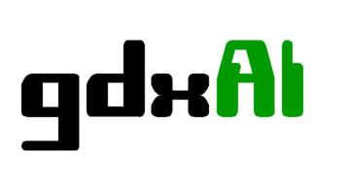

What’s Libgdx-ai ?
- It's an artificial intelligence framework, entirely written in Java

- The gdxAI framework makes use of a limited number of classes from the libGDX framework, but since version 1.4.1 the gdx-ai extension has been moved to a separate repository under the libGDX umbrella

- Current version 1.8.1
Main Resources
- Infraestructure
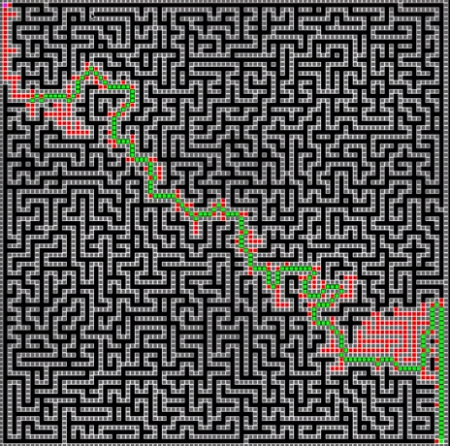
  - Message handling
  - Scheduling
- Movement Ai
  - Steering Behaviors
  - Formation motion
- Pathfinding

  - Pathfinding Api
  - A*
  - Hierarchical Path Finder
  - Path Smoothing
- Decision Making
  - State Machine
  - Behavior Trees
Pathfinding Api
- To find a path inside a graph, it provides a different interfaces

- The GraphPath
  - Basically represents all possible paths inside a graph
- The Heuristic
  - It’s a fuction that generates estimated costs to move from one point to another
- The PathFinder
  - Using the graph calculates all possible ways to reach the objective, using also the heuristic selects de shortest one in terms of time

A*
- A* is a heuristic search algorithm for finding a path through a graph, is 2d or 3d games that graph should be the map
      - A* is not inherently a multi-agent path finding algorithm, but exists differents adaptations for that situations
      - It always find the shortest path
      - If a path exists, it will be found

Hierarchical Path Finder
- Plans a route in much the same way as a people would
      - Each stage of the path will consist in another

Path Smoothing
- Uses a SmoothableGraphPath and finds a path by linking directly the nodes that are in line of sight
      - if they were connected in the graph, the pathfinder would have found the smoothed route directly, unless their connections had dramatically large costs

